FEATURES
High Quality and Cost-effective 50/125 Micron OM3 Multimode Fiber Optic Cable
The 50/125 micron OM3 multimode fiber optic cable is suitable for 10GBase-SR, 10GBase-LRM, Faster Ethernet and 40/100Gb applications, such as in data center, telecom room, server farms, cloud storage networks, and any place fiber jumper cables are needed. It meets RoHS compliant and cable is optically tested for insertion loss to ensure high quality.
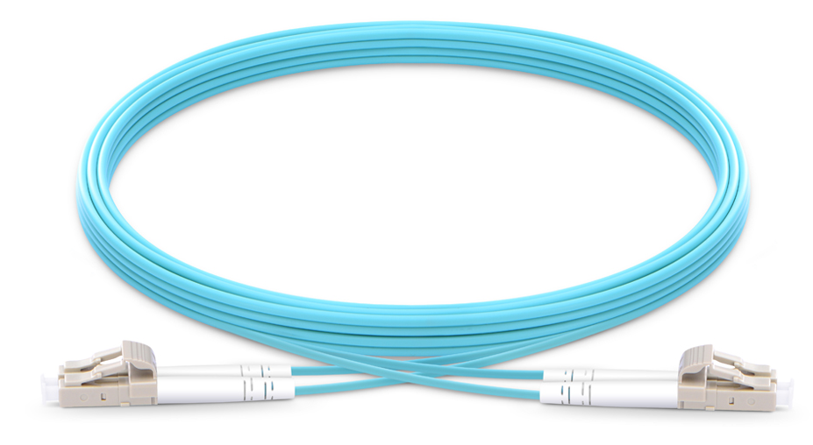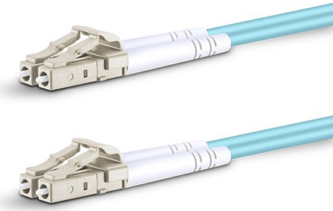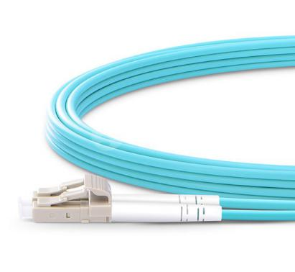

also provides a full set of OEM services, such as fiber connector, length, color, fiber grade, specification, material, package etc.

Technical Information
Connector Type | LC to LC | Jacket OD | 2.0mm
Fiber Type | 50/125ìm | Jacket Color | Aqua
Polish Type | UPC to UPC | Wavelength | 850/1300nm
Fiber Count | Duplex | Jacket Material | PVC
Insertion loss | ≤0.3dB | Attenuation at 850nm | 3.0 dB/km
Return loss | ≥20dB | Attenuation at 1300nm | 1.0 dB/km
Minimum Bend Radius | 30mm | Fiber Grade | G.651
Polarity | A(Tx) to B(Rx) | Operating temperature | -40~75°C

High Quality Fiber Optic Cable Guarantee
End face test, insertion loss test and other tests of fiber patch cable ensure high-speed Ethernet network equipment connections.
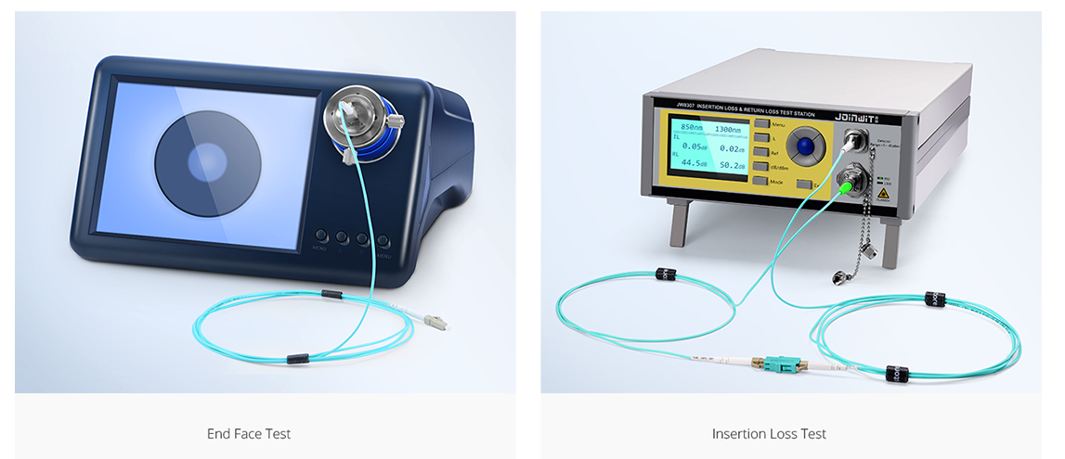
Quality Certification
Quality and standards are the foundation of FOCC. We are dedicated to providing customers with the outstanding, standards-compliant products and services.
FOCC has passed many quality system verifications, like ISO9001 and RoHS, established an internationally standardized quality assurance system and strictly implemented standardized management and control in the course of design, development, production, installation and service.


Range of application
Multimode Direct Connection for 10G SFP+ Transceivers
Just using an OM3 duplex fiber patch cable, you can connect two 10G switch with SFP+ transceivers fast. The following image shows two SFP+ transceivers connected by an OM3 fiber patch cable.

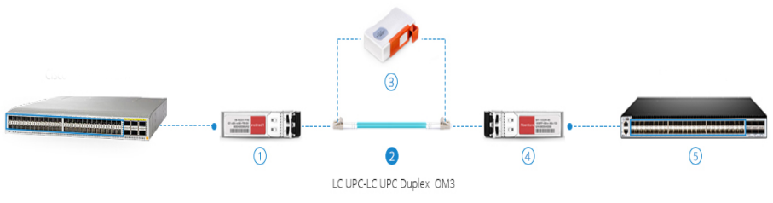
Item No. | Description
1 | Cisco SFP-10G-SR Compatible 10GBASE-SR SFP+ 850nm 300m DOM Transceiver
2 | 1m (3ft) LC UPC to LC UPC Duplex PVC(OFNR) OM3 Fiber Patch Cable
3 | Fiber Optic Cassette Cleaner for LC/SC/FC/ST/MU/D4/DIN Connector
4 | Generic Compatible 10GBASE-SR SFP+ 850nm 300m DOM Transceiver
5 | S5850-48S6Q (48*10GE+6*40GE) High Performance Data Center Switch

A Simple, Cost-effective Cabling in High-Speed Network
There are hundreds of cabling solutions for high-speed network, but how do you choose? The following easy, fast and cost-effective cabling solution of OM3 duplex fiber patch cable and 12 fibers MTP cassette may resolve your questions.
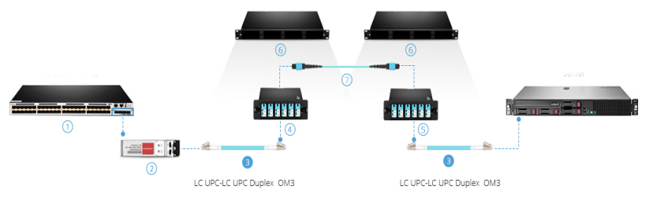
Item No. | Description
1 | S5800-48F4S (48*1GE+4*10GE) High Performance Data Center Switch
2 | Generic Compatible 10GBASE-SR SFP+ 850nm 300m DOM Transceiver
3 | 1m (3ft) LC UPC to LC UPC Duplex PVC(OFNR) OM3 Fiber Patch Cable
4 | MTP-12 to LC 12 Fibers MPO/MTP Cassette, OM3, Type A
5 | MTP-12 to LC 12 Fibers MPO/MTP Cassette, OM3, Type AF
6 | 1RU Rack Mount Fiber Enclosure unloaded
7 | 5m (16ft) MTP Female to MTP Female 12 Fibers OM3 Trunk Cable, Type A

Product Highlights
Industry Standard Fiber Optic Cable
The fiber optic cable has industry standard flammability rating OFNR (Riser) jacket and duplex fiber connector which meets EIA/TIA 604-2 for high speed cabling networks.

Premium Zirconia Ceramic Ferrule
- Quality zirconia ceramic ferrule ensures optimum IL and RL, giving you excellent performance.
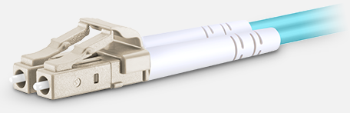

Perfect Combination of Fiber Core & Cable Diameter
- 50/125um fiber core and 2.0mm cable diameter provide maximum protection .
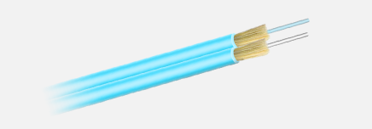

Clear Cable Printing
- Fiber type, cable jacket etc. in the bunch help clarify and recognize different cables.
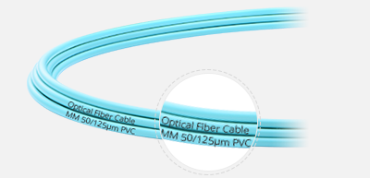

Packing & Labeling

Eco-Friendly Packaging & Labeling
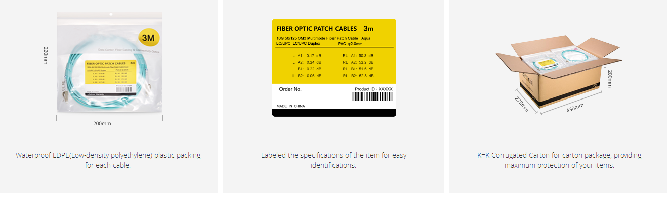
This easy to take and well-protected fiber optical cable package has been labeled and marked by FOCC as default. Customized label or package solution are available on request.
Questions & Answers
Question:
Are these cables compatible with a variety of modules?
Answer:
Yes, LC cables can be compatible with SFP, SFP+ (BIDI SFP+), XFP. SC cables can be compatible with BIDI SFP, GBIC, X2 and XENPAK.
Question:
What's the difference between orange fiber optic cable and aqua? By Joseph Smith
Answer:
Both OM1 and OM2 are typically orange, the difference being the size, which is why you see both orange 50 and 62.5 micron cables. OM3 and OM4 are typically aqua. Higher speed applications require OM3 and OM4 (or better) for certain distances. And they have different data rate. OM1 and OM2 can support 1Gb and 10Gb speeds, OM3 and OM4 can support 1Gb to 100Gb speeds.

